Sept. 11th 2019 Lab section PRA0103

Student Name and Number Adam Carnaffan 1005069432

Student Name and Number Hyungin (Fred) Chun 1004924834

The report submission deadline is 23:55 on Tuesday, next week after the session. The report is uploaded to the Quercus assignment “Exercise” as a PDF or MS Word file.

**EXERCISE: THE OUTPUT RESISTANCE OF A POWER SUPPLY**

**Objectives:** to review basic electrical measurement techniques;

analyze uncertainties of direct and indirect measurements; understand error propagation;

apply curve fitting to the set of data points;

calculate uncertainty in linear fit.

**I. Introduction**

Any source of electrical energy (generator, battery, thermocouple, etc.) with no load attached to it produces voltage potential across the terminals called an electromotive force (*emf*), or an open-circuit voltage*, V****∞***.

This number does not completely specify the power supply. In a closed circuit, a current ***I*** will be drawn from the power supply, and the voltage at the terminals, ***V***, called *the terminal voltage*, will typically fall below *V****∞***:

A plot of the terminal voltage ***V*** vs. current ***I*** may look like in Fig. 1.

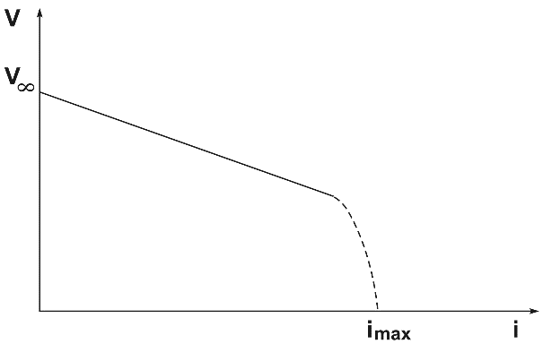

FIG.1: Terminal voltage vs. current

**Imax I**

Linear

Nonlinear

Many power sources will exhibit a linear variation of *V* for small current values, followed by a nonlinear behaviour at higher currents. The linear part of the curve can be described by

***V = V∞ - RI***, (1)

where ***R*** is the *output resistance of the power source*. In this linear regime, according to Thevenin’s theorem, the power source is completely represented by this equivalent circuit as in Fig. 2.

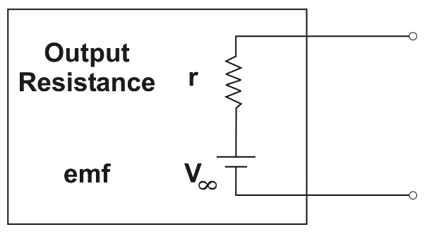

**R**

Fig. 2. Equivalent circuit of an electric power source.

The output resistance, ***R***, can be determined by attaching different external resistances of the load, ***Rl*,** to the power source, and measuring the current and voltage with a multimeter.

Figure 3 shows two possible ways of doing this. Both would be equivalent if the multimeter were ideal. However, you will measure with the real, not ideal, multimeters.

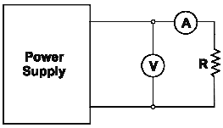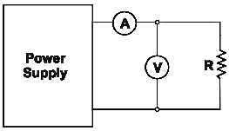

Option 1 Option 2

Power source

Power source

***Rl***

***Rl***

Fig. 3. Possible circuits for determining the output resistance of a power source.

**Question 1: Without connecting circuits and making measurements, what is the expected difference in readings of a voltmeter and an ammeter connected in Option 1 and in Option 2**? **Explain.**

Option 1 is expected to have a higher voltage reading than Option 2 because some of the output voltage from the power source in Option 2 is consumed by the ammeter’s internal resistance before reaching the voltmeter. Option 2 is expected to have a higher current reading than Option 1 because some of the output current from the power source in Option 1 flows through the voltmeter’s internal resistance due to Kirchhoff's current law.

**Question 2: To calculate the resistance of the power source, you will need to know the internal resistance of the voltmeter and the ammeter. How can you find these values making measurements of current and voltage first with the Option 1 circuit and then with the Option 2 circuit? Derive the formulae for the internal resistance of the voltmeter and the ammeter basing on the results of the described two measurements. Give the solution in general, i.e. without numbers.**

***Note.*** If you experience difficulties with typing complicated formulae, you may write a formula by hand,take a photo of the formula and place it into your report. All symbols must be clear and legible. A photo is a figure and, as a figure, must have a caption with description of the contents.

Option 1

*• V: voltmeter reading*

*• IA: ammeter reading*

*• RA: internal resistance of ammeter*

*• Rl: load resistance*

*• V + IA(RA + Rl) = 0 (Kirchhoff's voltage law)*

*• IA(RA+Rl) = -V*

*• RA+ Rl= -V / IA*

*• RA= -V / IA- Rl*

Option 2

*• V: voltmeter reading*

*• IA: ammeter reading*

*• Il: load current*

*• RV: internal resistance of voltmeter*

*• Rl: load resistance*

*• V + IlRl = 0 (Kirchhoff's voltage law)*

*• IlRl= -V*

*• Il= -V / Rl*

*• IA= Il+ V / RV (Kirchhoff's current law)*

*• IA- Il= V / RV*

*• RV(IA - Il) = V*

*• RV= V / (IA - Il)*

*• RV= V / (IA - (-V / Rl))*

*• RV= V / (IA + (V / Rl))*

    Therefore, the derived formulae are *RA= -V / IA- Rl* for the internal resistance of the ammeter and *RV= V / (IA + (V / Rl))* for the internal resistance of the voltmeter.

**II. Experiment:**

* For all resistors provided, measure resistance by the multimeter set to ohmmeter. Create a table for all obtained values with their uncertainties as the reading uncertainties.

Table 1. Resistance of Available Resistors [Ω]

|  |  |  |  |  |  |  |  |  |  |  |  |  |  |
| --- | --- | --- | --- | --- | --- | --- | --- | --- | --- | --- | --- | --- | --- |
| *Rl1*,  Ω | *ΔRl1*,  Ω | *Rl2*,  Ω | *ΔRl2*,Ω | *Rl3*,  Ω | *ΔRl3*,Ω | *Rl4*,  Ω | *ΔRl4*,Ω | *Rl5*,  Ω | *ΔRl5*,Ω | *Rl6*,  Ω | *ΔRl6*,Ω | *Rl7*,  Ω | *ΔRl7*,Ω |
| *1.2e6* | *1e5* | *82.8e3* | *1e2* | *34.0e3* | *1e2* | *8.2e3* | *1e2* | *845* | *1* | *677* | *1* | *327* | *1* |

* For assembling your electric circuit, select 4 different resistors from the set.

**Question 3: Briefly justify your choice.**

R11, R13, R15, and R17 were selected for the widest range of resistance values. However, R11, R12, R13, and R14 should have been selected as they have the highest resistance values, which keep the drawn current values small and the variation of V in the linear regime.

**Assemble a circuit for Option 1 (Fig. 3). Sketch it or photograph it with your smartphone, and include the sketch/picture in your report. List the elements of the circuit in a caption.**

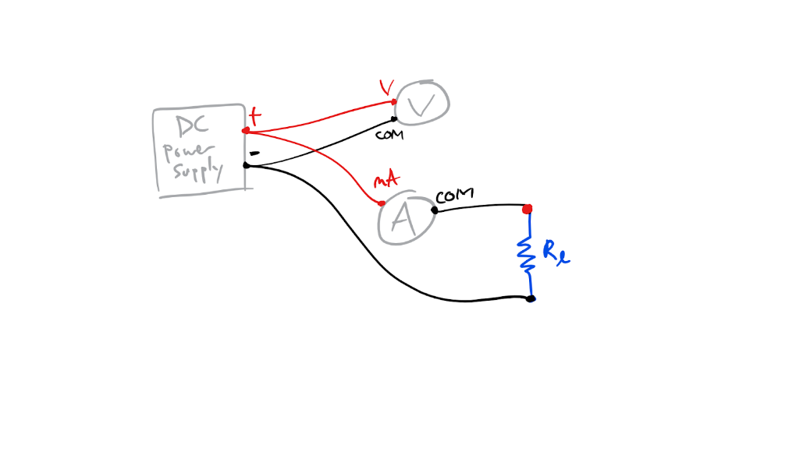

Fig. 4. Sketch of the circuit for Option 1 composed of a DC power supply, voltmeter, ammeter, load resistor, and cables.

Table 2. Selected Resistors & Results for Option 1

|  |  |  |  |  |  |  |  |  |
| --- | --- | --- | --- | --- | --- | --- | --- | --- |
| Option 1 | | | | | | | | |
|  | Resistance ***Rl***, Ω | Uncertainty Δ***Rl***, Ω | Voltage ***V***, V | Uncertainty Δ***V***, V | Current ***I***, mA | Uncertainty Δ***I***, mA | Resistance of a meter ***RA***, Ω | Uncertainty Δ***RA***, Ω |
| 1 | 1.2e6 | 1e5 | 6.55 | 0.01 | 0.005 | 0.001 | 400 | 1 |
| 2 | 34e3 | 1e2 | 6.55 | 0.01 | 0.191 | 0.001 | 400 | 1 |
| 3 | 845 | 1 | 6.54 | 0.01 | 7.63 | 0.01 | 293 | 1 |
| 4 | 327 | 1 | 6.52 | 0.01 | 19.30 | 0.01 | 293 | 1 |
|  |  |  |  |  |  | Average: | 346.5 | 1 |

* Plot ***V*** vs ***I*** and apply a linear fit to determine the slope *m1* and its uncertainty.

Figures 5 & 6: Slope found at -0.0016 ± 0.58 with reduced chi-squared of 0.0119 and intercept at 6.55 ± 6.1

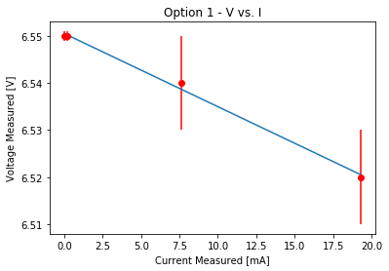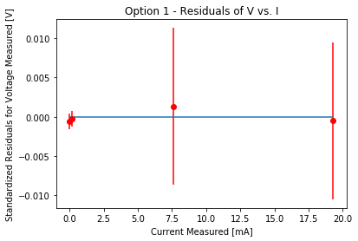

**Assemble a circuit for Option 2 and enter all measurements into Table 3.**

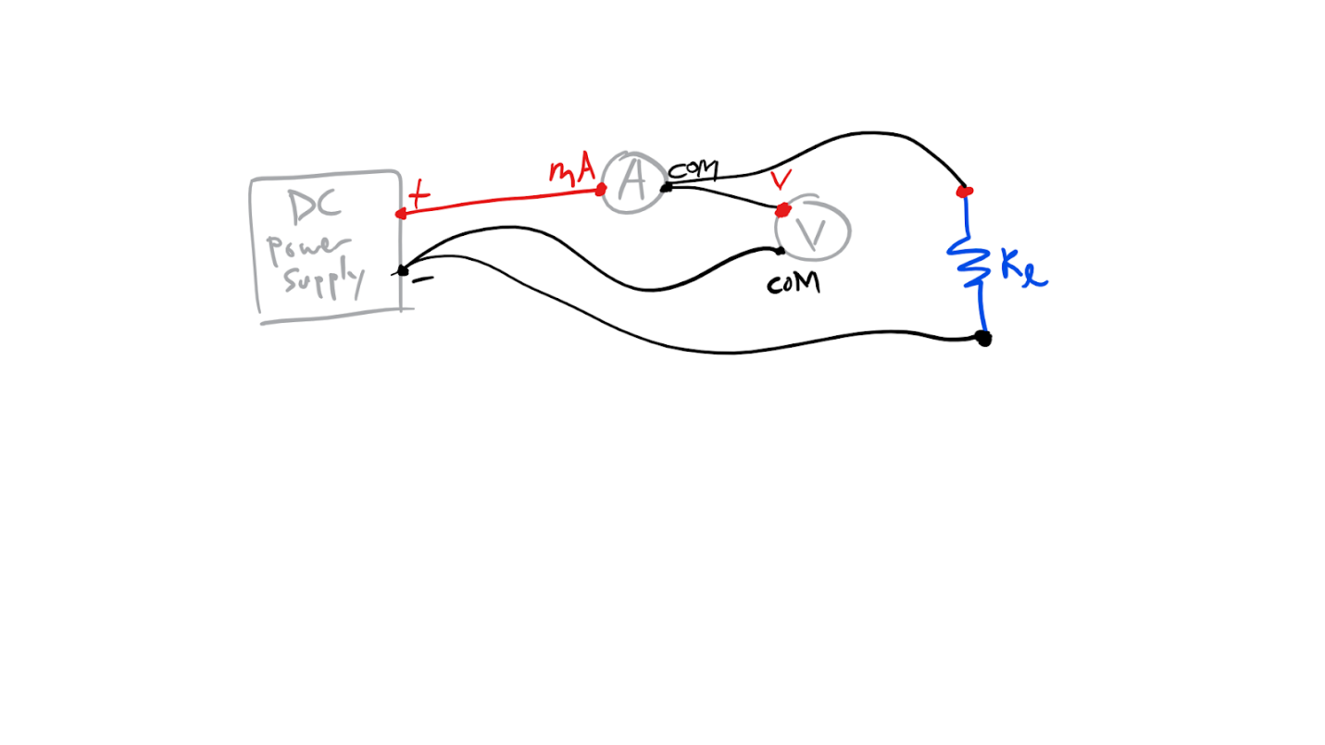

Fig. 7. Sketch of the circuit for Option 2 composed of a DC power supply, voltmeter, ammeter, load resistor, and cables.

Table 3. Selected Resistors & Results for Option 2

|  |  |  |  |  |  |  |  |  |
| --- | --- | --- | --- | --- | --- | --- | --- | --- |
| Option 2 | | | | | | | | |
|  | Resistance ***Rl***, Ω | Uncertainty Δ***Rl***, Ω | Voltage ***V***, V | Uncertainty Δ***V***, V | Current ***I***, mA | Uncertainty Δ***I***, mA | Resistance of a meter ***RV***, Ω | Uncertainty Δ***RV***, Ω |
| 1 | 1.2e6 | 1e5 | 6.57 | 0.01 | 0.006 | 0.001 | 657.4 | 8.4 |
| 2 | 34e3 | 1e2 | 6.55 | 0.01 | 0.192 | 0.001 | 34.5 | 0.06 |
| 3 | 845 | 1 | 6.48 | 0.01 | 7.65 | 0.01 | 0.848 | 0.002 |
| 4 | 327 | 1 | 6.34 | 0.01 | 19.35 | 0.01 | 0.328 | 0.002 |
|  |  |  |  |  |  | Average: | 173.2 | 2.116 |

* Plot ***V*** vs ***I*** and apply a linear fit to determine the slope *m2* and its uncertainty.

Figures 8 & 9: Slope found at -0.011 ± 0.58 with reduced chi-squared of 0.953 and intercept at 6.56 ± 6.1

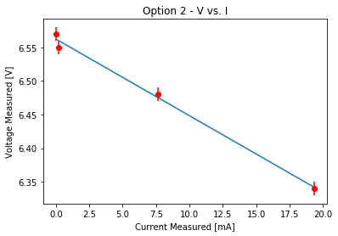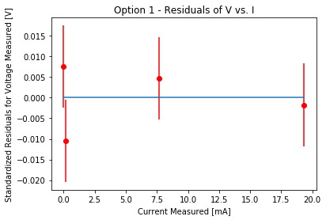

Derive a relationship among *m1*, ***RV*** and ***R1*** to find the output resistance and its uncertainty. Show your work for derivation of the propagated uncertainty of ***R1***.

* *V/R1 = V/RV + IA (Kirchhoff's current law)*
* *V = R1(V/RV + IA)*
* *R1 = V / (V/RV + IA)*
* *1/R1 = (V/RV + IA) / V*
* *1/R1 = 1/RV + IA/V*
* *1/R1 = 1/RV + m1*
* *1 = R1(1/RV + m1)*
* *R1 = 1 / (1/RV + m1)*

**Uncertainty**



Derive a relationship among *m2*, ***RA*** and ***R2*** to find the output resistance and its uncertainty. Show your work for derivation of the propagated uncertainty of ***R2***.

* *V = IA(RA + R2) (Kirchhoff’s voltage law)*
* *V / IA = RA + R2*
* *m2 = RA + R2*
* *R2 = m2 - RA*

**Uncertainty**

**

Show the output resistance of the DC power supply as: ***R1* =** ( **209.5 ± 2.2** ) Ω and ***R2* =** ( **345.1 ± 1.2** ) Ω.

Write a brief conclusion on the difference between the two results.

In conclusion, the orientation of a circuit can have a large impact on the internal resistance of a power supply, impacting the accuracy of an experiment in turn. To mitigate this effect, circuits oriented similarly to Option 1 are preferable for reducing the internal resistance of power supplies.